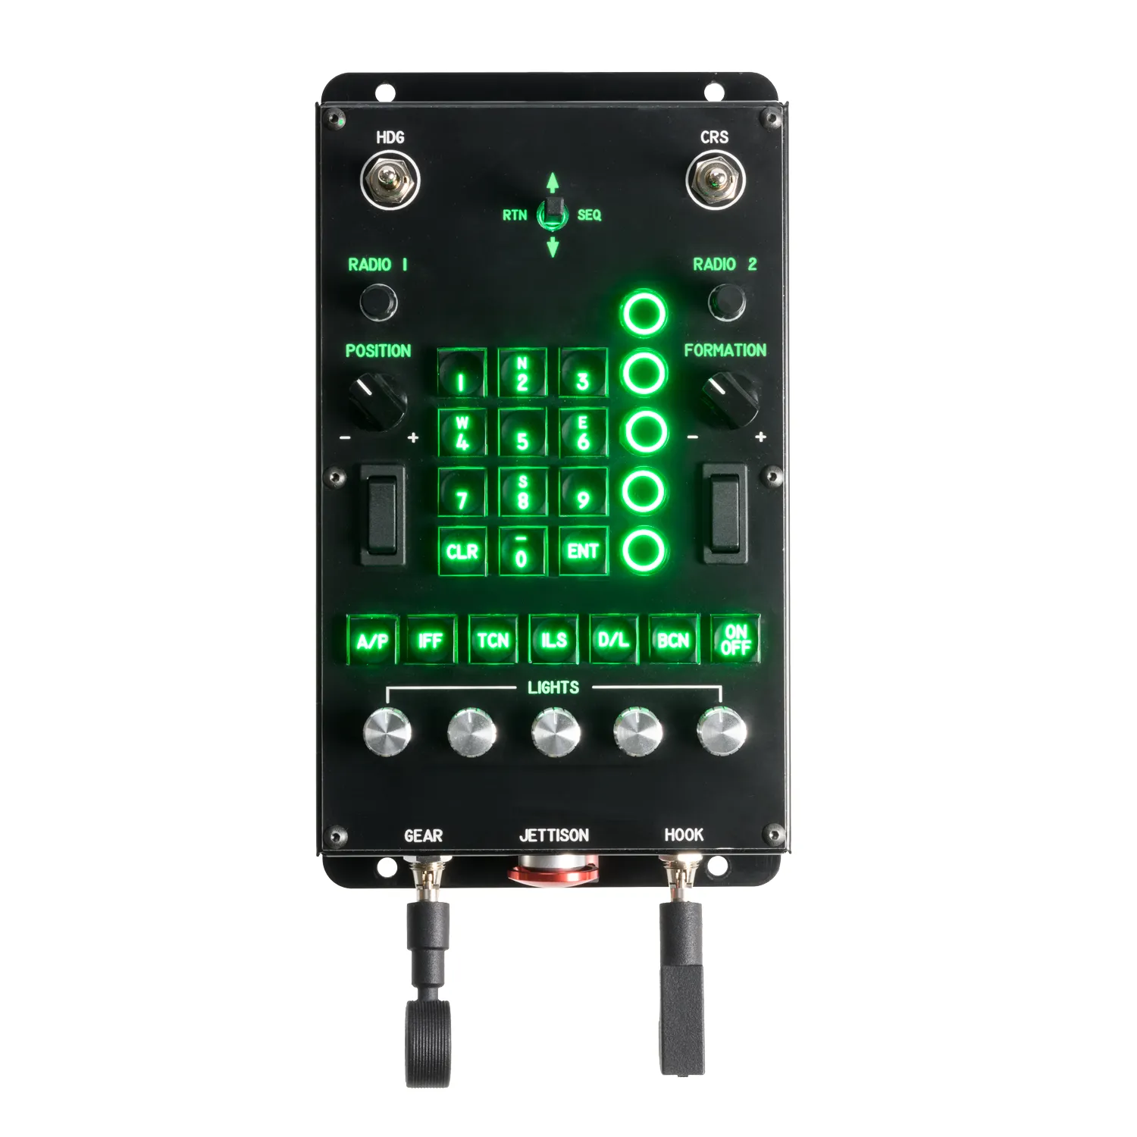
105 - Controls – Multifunction Button Box
U=Up, D=Down, N=Neutral, F=Forward, B=Backward, L=Left, R=Right, P=Press, S-*=Shift-*, L-*=Long-*

HDG Momentary Switch
- L: --
- R: --
CRS Momentary Switch
- L: --
- R: --
Dobber Switch
- U: --
- D: --
- L/RTN: --
- R/SEQ: --
- P: --
Radio 1 Encoder
- CCW: --
- CW: --
- P: --
Radio 2 Encoder
- CCW: --
- CW: --
- P: --
Position Knob (left side): --
Formation Knob (right side): --
UFS Option Pushbuttons
- --
- --
- --
- --
- --
Left Rocker: --
Right Rocker: --
Mode Buttons:
- A/P: --
- IFF: --
- TCN: --
- ILS: --
- D/L: --
- BCN: --
- On/Off: --

Lights Knobs
- --
- --
- --
- --
- --
Gear Switch: --
Hook Switch: --
Jettison Button: --

(to adjust lights, hold A/P and TCN and turn the Radio 2 Encoder)

